Warner Creek Board Meeting
Feb, 2 2023

AGENDA

Call to order
Attendance: Chris, Bob, John, Megan, Colleen, Anh
Absent: Eric (meeting conflict)

Approval of previous meeting minutes
- President
  - Discussion with legal date
  - Megan, Chris sent out survey results! Good work!
    - Survey feedback - was generally positive, one resident was concerned about data being shared with third party companies
      - All surveys were returned without any personally identifying information, so there wasn’t any mechanism by which data could have been leaked
- Per the advice of Compass, John proposes changing the number of board positions to seven
  - Bob seconds
  - Approved unanimously
- Chris/Megan need Compass to send notice when resident moves out and new resident moves back in, so email list can be updated
- Discussion regarding end of Compass contract:
  - Need to research alternative platforms to act as a self-managed resident portal, to share the workload
  - Compass doesn’t build their own platform, contracts the same platforms we can use
  - Need to continue with Compass through annual meeting
    - May 3rd is 90 days
    - Annual meeting prepped in April

Committees Updates

- Treasurer -- Colleen
  - New Budget - Compass didn’t send requisite information
  - Colleen is having to contact Compass 4 or 5 times in a row to get a response
    - (We the board forgot to send Stacey the Zoom link for tonight’s meeting)
    - Flag at crosswalk is in disarray, needs to be taken care of
- ABR – John
  - Would like to have trash container guidelines and pictures distributed to residents during next Compass email
    - We set a policy, we need to distribute this policy to provide guidance
    - Need a due date
  - Resident is requesting exception to trailer policy due to external parties requiring compliance
    - We don’t have an exception process in place
    - There is an explicit bylaw for trailers
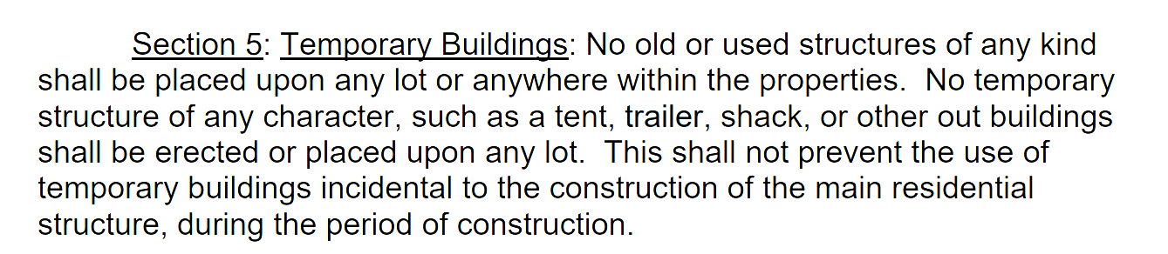
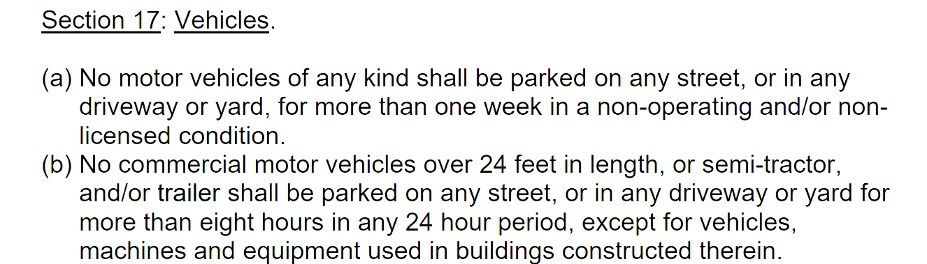

- Welcome -- Megan
  - New welcome committee met with Liz a few weeks ago, have started work on sending out welcome packages
  - Need more information from Compass for regular roster updates
- Activities -- Megan
  - Many activities are planned! Committee met a few weeks ago
  - Easter Egg hunt, food trucks (7 scheduled), confirmation of garage sale weekend after Mother’s Day with other 2 subdivisions, Bear Claw Coffee Company will have a food truck for the garage sale!
- Parks (Bob)
  - Handicap swing to be installed
- Chris will take lead on getting annual meeting scheduled
- Bob motions to adjourn
  - Meeting adjourned

New Business

Welcoming committee transition/process

Previous meeting minutes —-----------------------------------------

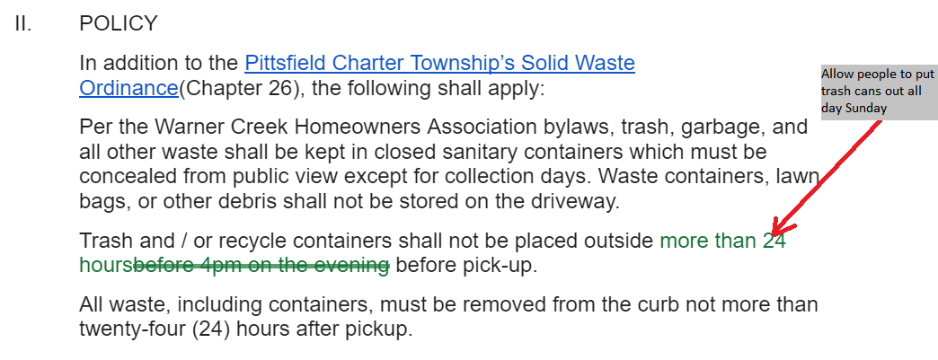
Warner Creek Board Meeting Minutes
Dec. 7, 2022

Call to order
Attendance: Chris, Eric, Bob, John, Megan, Stacey S., Anh

Approval of previous meeting minutes
- President
  - Discussion with legal
  - Sending out sign policy
    - Vote to revoke 72 hour limit on specific signs is approved

Committees Updates

- Treasurer -- Colleen
  - Discussion of account balances with specific residents
- ABR – John
  - No updates
- Welcome -- Megan
  - Waiting on information from Liz
- Activities -- Megan
  - Activities have been successful
- Parks (Bob)

New Business

- Survey results (discussion was very quick and notes were hard to take)
  - Megan: People want friendly neighborhood
  - Anh: Agreed with Megan on friendliness
  - John: Question 1 vast majority 10+ years, could have added additional useful options. Question 3 - no consensus, so status quo should remain.
  - Chris: No need to email out individual results, or questions about demographics. Compass questions won’t be useful to subdivision either. We should focus on conveying responses regarding capital improvements, activities, fence question, sidewalk enforcement (or lack thereof beyond Pittsfield)
    - Concerned about sending too much information out that could dox respondents
  - Eric: Many households without kids is surprising.
  - Bob: People tend to want to be left alone, with less enforcement. Need for a management company needs to be communicated better. Wants to send out results as transparently as possible.
  - Bob: Motions to summarize survey, and send full results to subdivision, including full responses.
    - Discussion phase: John and Chris want to redact comments as the comments could reveal personal information or add fuel to the fire
      - Chris prefers to misalign free form comments so that they’re more anonymous, and was under the impression that they would be anonymous
    - Megan wanted to send out comments as well, as openly as possible
  - Bob: New motion to send out summary only, and the free form comments will be summarized in an easy to read format
- Next steps: Stacey will send Chris the updated email list, Chris will draft a response with Megan’s analysis (to be finalized by Megan), Chris will send draft to board, then send the survey out to updated Google Group for entire subdivision
- Concealment of trash cans – John
  - New images to discuss, showing pervasive non-compliance
  - Discussion on whether to send policy reminders to all residents, or specific residents who are violating the previously approved policy.
- Motion to amend trash policy (Less stringent time requirements)
  - Motion approved

Meeting Minutes
Nov 2, 2022

AGENDA

Call to order
Attendance: Chris, Bob, John, Megan, Colleen, Anh
Missing: Eric
(Liz and Stacey resigned)

- Bob motions to approve meeting minutes in September, John seconds
  - No discussion
  - Passes unanimously.

- President
  - Discussion with legal RE: fences - Compass wants to meet with legal to discuss the legal limits, ramifications, process, etc, for updating bylaws surrounding fences
    - Nobody is opposed to this meeting
    - Bob will tentatively schedule for middle of December
  - Finalize sign policy via email

Committees Updates

- Treasurer -- Colleen
  - No significant updates
  - Future agenda item to address - $25 discount for annual meeting
    - As previously discussed, legal basis is that the rebate needs to go away
  - Compass is largest expenditure
- ABR – John
  - No updates
- Welcome -- Megan
  - No updates
- Activities -- Megan
  - Fall festival went really well, food guesstimate was very accurate
  - Activities committee will look at the results of the survey to see where to spend efforts
- Parks (Bob)
  - Resident asked for swing for disabled kids - Bob is working with Compass on this

New Business

Review of compass management’s performance.
- Bob: This isn’t an immediate vote to end our relationship with Compass, but is the initial discussion. If we find we don’t want to go in this direction, we would have to develop a plan to pull out of this agreement.
- Anh:
  - Positives:
    - ABR process is much easier than before.
  - Negatives:
    - Compass isn’t very responsive
    - Status letter debacle (Compass overcharging for status letter)
- Chris:
  - Hasn’t been on board without Compass, so looking at this through limited lens
  - Positives:
    - From resident survey, supermajority of residents who interact with Compass had their issues resolved
  - Negatives:
    - The cost analysis of Compass isn’t accurate to Chris
      - For example, not having to pay legal fees was previously cited as a reason to go with Compass, but if we were in legal trouble, we’d still have to pay legal fees
    - Bottom line: from surveys, far fewer residents voiced support for Compass than against Compass.
      - We’re going against the will of Warner Creek
- Colleen:
  - Cost of Compass is questionable, but a management company is still a benefit moving forward.
  - Compass takes their time getting reimbursements out
- John:
  - Positives:
    - Financial reporting
    - ABR approval process, record keeping
    - Collected delinquent dues
    - We receive good advice
    - Compass was recommended by Warner Creek’s own attorney
  - Areas that need to be improved:
    - Site visits need to be reported to Warner Creek Board
      - Need to know what bylaws are being violated
    - Return phone calls and emails
    - Need to know what residents are being fined
  - What board needs to do:
    - Give list of things to Compass to improve
    - Devote more time to bridge the gap between self management and third party management
    - Give Compass one more year with list of things to improve on
- Megan:
  - Negatives:
    - The fact that most people didn’t interact with Compass means we don’t necessarily need them in the first place
    - Megan things that 32% of residents not feeling their issue was resolved is a negative
    - Reimbursements do take forever, problematic for Board members who have to front the cost of events/etc with their own finances
    - Leans towards no
- Bob:
  - Positive:
    - Compass is effective at mailing out communication
    - Assists in evenly enforcing bylaws
    - Reduced delinquencies to zero dollars
    - Calling contractors is a huge time investment, Compass doing this reduces a lot of work for the board
      - Bob tried to get the playground fixed for years, Compass finally helped get it done
    - Ensured we’re following a legally sound process for voting at annual meetings
  - Negative:
    - Reimbursement timing is unacceptable
    - Neighbors not hearing from Compass is unacceptable
    - Stacey Sherille is the only person we talk to - if she’s out, we have no point of contact
  - Summarizes everyone’s thoughts, proposes that we proceed for another year
    - During this year, we evaluate Compass quarterly
    - 9 months from now, we definitively decide on a plan moving forward
- The contract isn’t a yearly contract, the only requirement is a 3 month notice
  - Colleen: Willing to continue, if we evaluate after Q1 2023, and not 9 months from now
    - Chris agrees
  - Megan volunteers to take on the work of researching management company alternatives
- Next Annual meeting is going to be in April
  - We’ll have a go vs. no go prior to April
- Need to draft a list of deficiencies to send to Compass, send to Compass, then evaluate in February
  - Bob asks each board member to write to him several areas where Compass falls short, so we can send to Compass
  - Colleen, John and Bob will have meeting with Stacey with expectations
- December board meeting will still happen, will evaluate survey results
- John wants to send out guidelines on construction for trash concealment

September 7,2022 minutes

Attendees: Bob, John, Stacey S., Liz, Stacey Page, [Eric, Anh]

Not an official meeting. Do not meet quorum, but wanted to meet for the resident who was told that we would be meeting tonight. The resident did not join the meeting.

** Eric & Anh joined. We’re now at quorum.

Reminder to Board Members:
- Don’t use FB. It’s ok to post on FB, and ok to say you’re on the board, but please don’t say that you’re speaking for the board.
- FB is not an approved communications tool.
- We want to defend ourselves, but will never please all residents. We may always be held in the worst light by residents b/c we’re the ones expected to uphold the rules and manage compliance. We’re doing our job. And we can continue to improve our communication and keep doing our job.

Approval of meeting minutes:
- John has a correction for the minutes. James Blackburn has been responsive and does want to continue to be on the ABR.
- Move to approve august meeting minutes. John 2nds. Everyone voted to approve the meeting minutes from aug.

ABR updates:
- Winding down on construction projects b/c of season change.
- Would like to get some info for pre-approved trash can concealment for when those requests come.
- July 10 was the last submission for approval.

Welcome Committee:
- A couple new people, will get packets delivered.
- Courtney wants to join committee.
- Liz wants to look at survey results to see who else wanted to join.

Activities Committee:
Last food truck event tomorrow 9/7 (email has gone out)
Upcoming events: 10/23 Fall Festival; 12/11 Cocoa + Cookie Party with Santa Parade
New committee member arranged for picnic tables to be moved into a more accessible area along sidewalk > not just for events but for patrons of the park as well; so far I've seen a lot more people using them as I've driven/walked by!

Our committee currently has 5 members, including myself. 4 non-board members in the neighborhood have stepped up and been extremely helpful in ideating and executing these events. It's a really awesome group of neighbors, and I'm so appreciative of their help.

Next meeting (later this month) will be focused on the execution of our 2 upcoming events. After survey results come back, we will begin planning for 2023.

Treasurer:
- All delinquent residents have paid. There is one payment left for the most recent person on their payment plan.
- Even the person who was 10+ years in debt has paid in full.

Resident request:
- The resident who requested to join tonight’s meeting had asked for a 6 month budget/actual report to be posted and available for residents to view in the portal.
  - Resident did not join the meeting.
- Could also do the monthly expense reports for residents to see.
- Bob makes the motion to approve these 2 things and make them available for residents.
  - Residents will receive an email from compass when this document is available in the portal to view.

Policies:
Sign policy: take a look at the proposed/draft of the sign policy and add your comments/suggestions.

Next policy we will tackle will most likely be the social media / communication policy.

See the list of policies on our agenda: Resolution for Future HOA Policies

