Warner Creek Board Meeting
March, 2 2023

AGENDA

Call to order
Attendance: Bob, Megan, Chris, Eric, John
Absent: Colleen

Compass discussion

- Compass has proposed a reduced contract, as Warner Creek is not taking full advantage of the current contract
  - This new contract involves fewer site visits (one per month), a cap of attending 6 meetings per year, etc, but has a 1 year minimum
    - Bob tables the vote on this as the 1 year requirement is problematic for board members
    - (3/16 Post-meeting note - The 12 month contract is only to lock in the rate for 12 months. Warner Creek and Compass are both free to exercise the 90-day notice termination clause).
- Look at budget for 2023
  - Treasurer not present, Bob motions to vote for budget over email
    - Nobody opposes
- Review of prior meeting minutes regarding a $25 discount moving forward
  - Screenshot:
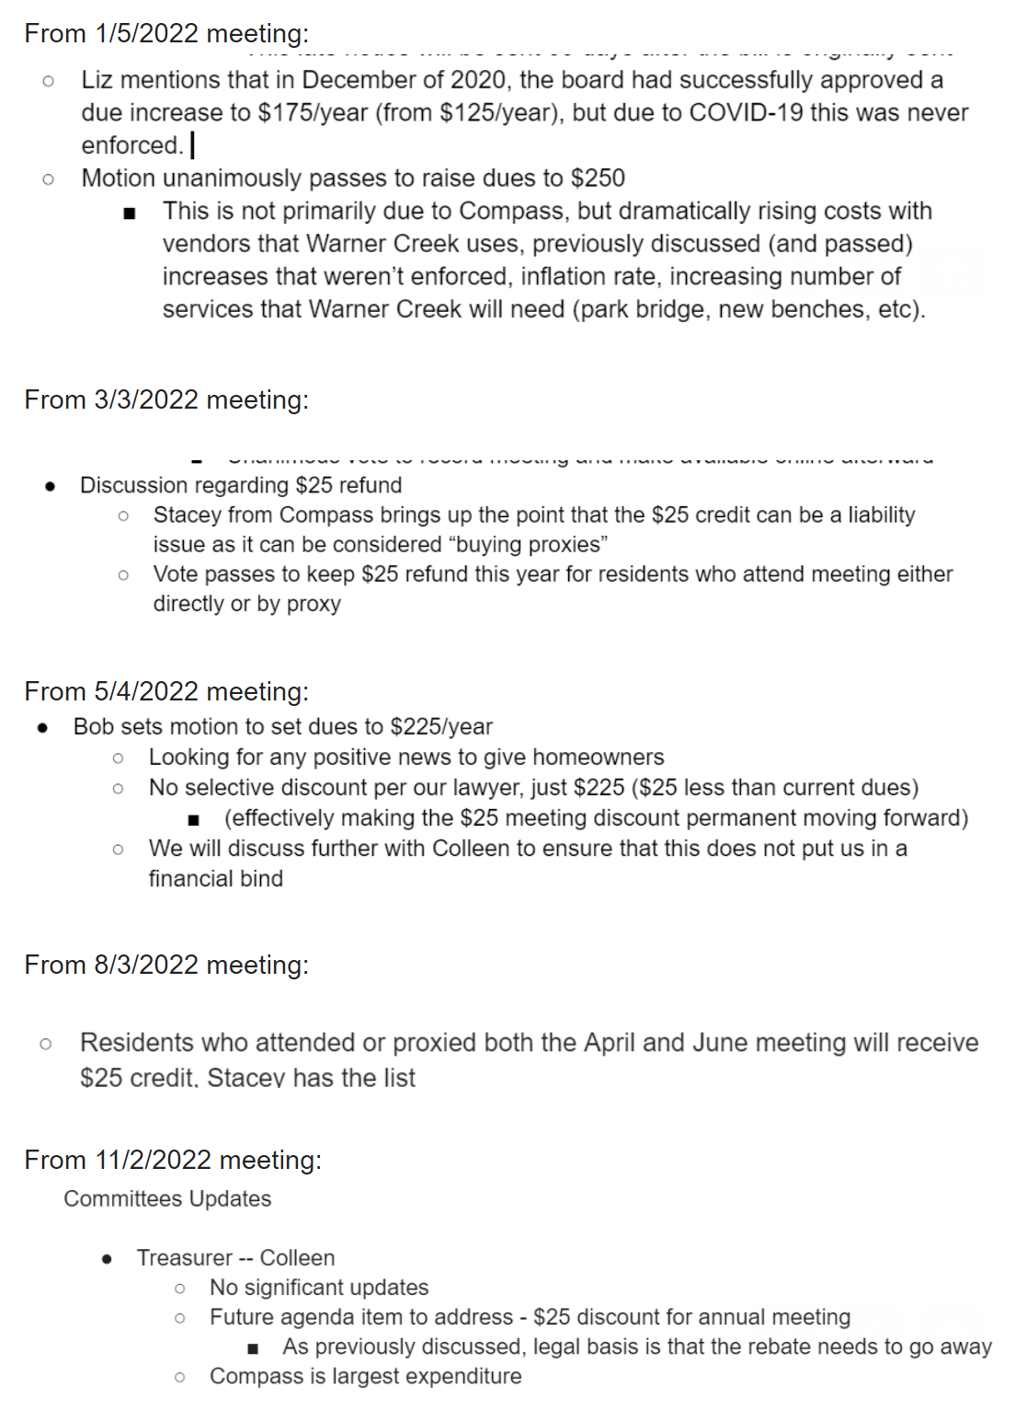
- Bob motions to set annual fees to $250 for this year
  - Costs have risen beyond last year, rapid inflation
  - Eric seconds
  - John suggests raising it an additional $25
  - Eric is concerned about the annual meeting not reaching quorum, with the absence of the discount
  - Chris wants to see if we can afford the $25 discount in light of the new Compass contract
  - Vote:
    - For: Bob, John, Eric, Megan
    - Opposed: Chris
  - Motion is approved
  - May 1st will be due date
- Annual Meeting tentatively May 4th
  - (3/16 Post-meeting note - Pittsfield Charter Township was unavailable on 5/4. The annual meeting is now planned to be held on 5/17).
  - Bob: Road construction presentation, asking if someone can research construction projects over the next year
    - John: Chris ask clerk’s office showing presentation on construction
    - Eric will reach out to Washtenaw Road Commission
  - Mention trash-can concealment policy
  - Research proposal for concrete sound barrier along Michigan Ave

Committees Updates

- Treasurer -- Colleen
- ABR – John
  - Stacey mentions that homeowner is requesting fence due to safety issue, proposes that this is a board issue and not ABR
- Welcome -- Megan
  - New resident, flyers, welcome packages
- Activities -- Megan
  - More updates closer to all of the events
- Parks (Bob)
  - Bob helped move branches that fell
  - Kids stood on toddler swings, broke, Compass took care of fix request
Approval of previous meeting minutes
- Bob motions, John seconds, voted for unanimously

Meeting adjourned by board

Previous meeting minutes —-----------------------------------------

Warner Creek Board Meeting
Feb, 2 2023

AGENDA

Call to order
Attendance: Chris, Bob, John, Megan, Colleen, Anh
Absent: Eric (meeting conflict)

Approval of previous meeting minutes
- President
  - Discussion with legal date
  - Megan, Chris sent out survey results! Good work!
    - Survey feedback - was generally positive, one resident was concerned about data being shared with third party companies
      - All surveys were returned without any personally identifying information, so there wasn’t any mechanism by which data could have been leaked
- Per the advice of Compass, John proposes changing the number of board positions to seven
  - Bob seconds
  - Approved unanimously
- Chris/Megan need Compass to send notice when resident moves out and new resident moves back in, so email list can be updated
- Discussion regarding end of Compass contract:
  - Need to research alternative platforms to act as a self-managed resident portal, to share the workload
  - Compass doesn’t build their own platform, contracts the same platforms we can use
  - Need to continue with Compass through annual meeting
    - May 3rd is 90 days
    - Annual meeting prepped in April

Committees Updates

- Treasurer -- Colleen
  - New Budget - Compass didn’t send requisite information
  - Colleen is having to contact Compass 4 or 5 times in a row to get a response
    - (We the board forgot to send Stacey the Zoom link for tonight’s meeting)
    - Flag at crosswalk is in disarray, needs to be taken care of
- ABR – John
  - Would like to have trash container guidelines and pictures distributed to residents during next Compass email
    - We set a policy, we need to distribute this policy to provide guidance
    - Need a due date
  - Resident is requesting exception to trailer policy due to external parties requiring compliance
    - We don’t have an exception process in place
    - There is an explicit bylaw for trailers
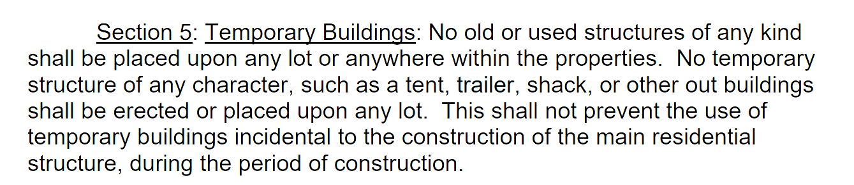
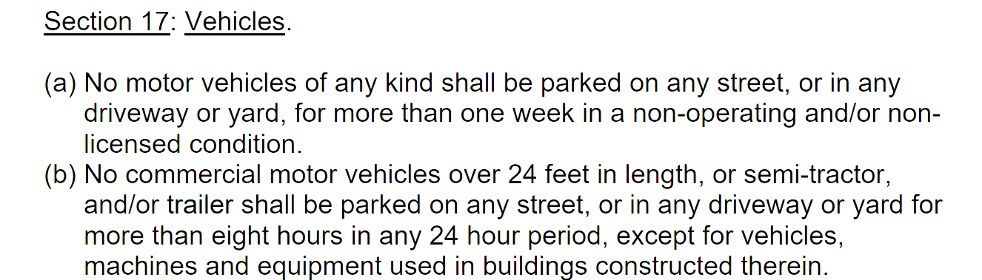

- Welcome -- Megan
  - New welcome committee met with Liz a few weeks ago, have started work on sending out welcome packages
  - Need more information from Compass for regular roster updates
- Activities -- Megan
  - Many activities are planned! Committee met a few weeks ago
  - Easter Egg hunt, food trucks (7 scheduled), confirmation of garage sale weekend after Mother’s Day with other 2 subdivisions, Bear Claw Coffee Company will have a food truck for the garage sale!
- Parks (Bob)
  - Handicap swing to be installed
- Chris will take lead on getting annual meeting scheduled
- Bob motions to end

