Warner Creek Board Meeting
April 6, 2022

AGENDA

Call to order

Approval of previous meeting minutes

Committees Updates
- Treasurer -- Colleen
- ABR – John
- Welcome -- Liz
  - Is the board being notified of home sales?
- Activities -- Stacey
- Parks (Bob)
  - Local Park - Inspection was delayed due to weather
  - Bridge committee– Reschedule meeting April 17th 3pm
  - Approval of bid to repair Platt Road Entrance Sign Map Electric
Agenda
- Liz
  - Easter egg hunt. how can we pay for it?
  - Can we respond on FB without escalating it?

Board Only only visible to board
Executive Session

- Late payment terms
  - Policy – Proposed policy
  - Action on those currently overdue

- Trash Cans
  - Compass to inspect neighborhood
    - 1st time –Trash cans left out on Tuesday after 9pm will get a warning letter
    - 2nd infraction – $25.00 fine
    - 3rd infraction – $50.00 fine
    - 4th infraction escalate to legal
  - Applies to where people store their trash cans

- Fences
  - Propose separate meeting with legal present
    - Policy vs Bylaw Change

- Schedule for other policy discussions
  - Fencing policy
  - Trash policy
  - Landscaping policy
  - Late Fee & Collection Policy
  - Fines policy
  - Communication & Social Media policy
  - Candidate qualifications policy
  - A policy of cooperation with Compass Management
  - Policy for dealing with bylaw offenders, chronic complainers, and those who sue us.

Meeting minutes:
- In attendance:
  - Bob, John, Stacey (Compass), James, Eric, Liz, Chris
    - Greg joined as a guest
- Prior meeting minutes approved
- Colleen not present for treasurer update
- Stacey: Dues mostly paid, 22 residents haven’t paid yet
  - Reserve account opened
- No ABR updates
- Welcome committee: Liz hasn’t received any notice regarding new owners or sales
  - Did receive a postcard from a realtor who sold a house in the neighborhood
  - Stacey from Compass will send an updated resident roster
- Stacey Page not present for activities committee update
- Prospective company for an Easter Egg hunt was discussed; board member would have to pay with PayPal and then have Compass reimburse from HOA funds
- Parks:
  - Local inspection delayed due to weather
  - Bridge meeting proposed for Sunday 3/17; Bob will send out an email to residents about it
- Bid to repair Platt Road entrance sign
  - Underground cable providing power to the lightbulb doesn’t have power
    - Cable repair costs $2,150
    - New light fixture would cost additional $175 if necessary
  - Solar light brought up as an alternative
    - Costs could be higher based on cost of battery maintenance and repair
  - Motion to approve repair costs if the company doesn’t believe that the solar light is sufficient
    - Stacey and the electrical company will review the solar option
    - Motion unanimously passes
- DTE - tree letter

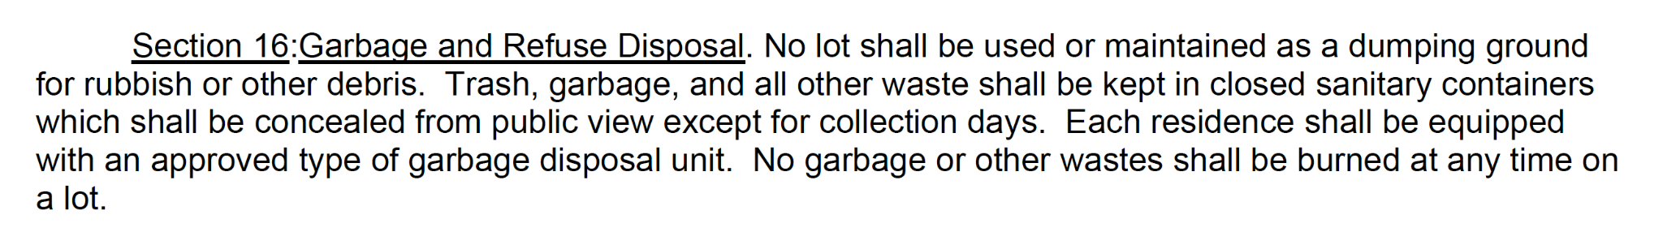

- Discussion regarding late payment policy
- Vote to approve Proposed policy passes
  - Vote to amend line 1 in the proposed policy to the fifteenth of every month passes
  - Vote to amend the notion to change delinquency from 60 days to 90 days passes
- Discussion regarding late fees for trash cans that are left out

Website info:
Garbage pick up is on Mondays. If garbage day falls on a Federal holiday, garbage pick-up will be on Thursday. Recycling is picked up every Monday. Another option to remove excess recycling or large trash items is through Pittsfield Township, vouchers are available for additional recycling needs or the disposal of large items.
Please remember to bring your garbage cans in promptly, according to current Pittsfield ordinance (Ord. No. 87, § 4, eff. 9-24-1975) trash cans should not be placed at the curb earlier than 6 pm the night before garbage day and should be removed by 6 pm the night of garbage day. Please keep your trash in a sealed container or packaged, tied securely to conform to Township trash policies.
​
The WCHA bylaws require garbage cans to be concealed when not by the road for garbage pick-up, please be considerate to your neighbors and hide your trash cans. A white utility fence has been approved by the ARB for use to conceal your trash cans by your home, it can be purchased from Lowe's (Barrette 46-in x 32-in White Vinyl Fence Panel: Item # 41009, as of 4/2015); you can also choose to use natural vegetation to conceal the trash cans. If you have another solution to concealing your trash cans, please submit it to the WCHA Board of Directors or the ABR for approval. For more information regarding garbage day and Recycling, please see: https://www.pittsfield-mi.gov/397/Rubbish-Recycling

